**Hosting a web Service**

Open Internet Information Service Manager (inetmgr.exe)

Expand->Sites->Default Web site

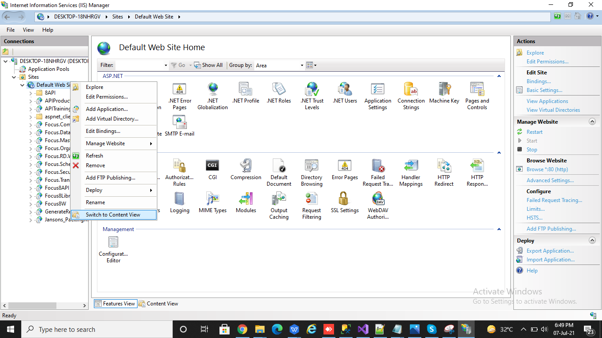

Right click on Default Website-> click add application.

Enter Alias as **IntrestReport**

If any other name given, module will not work. Map the path which should be available in **C:\inetpub\wwwroot**

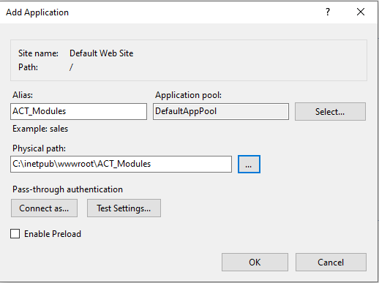

Click Ok. The website will be added like given below.

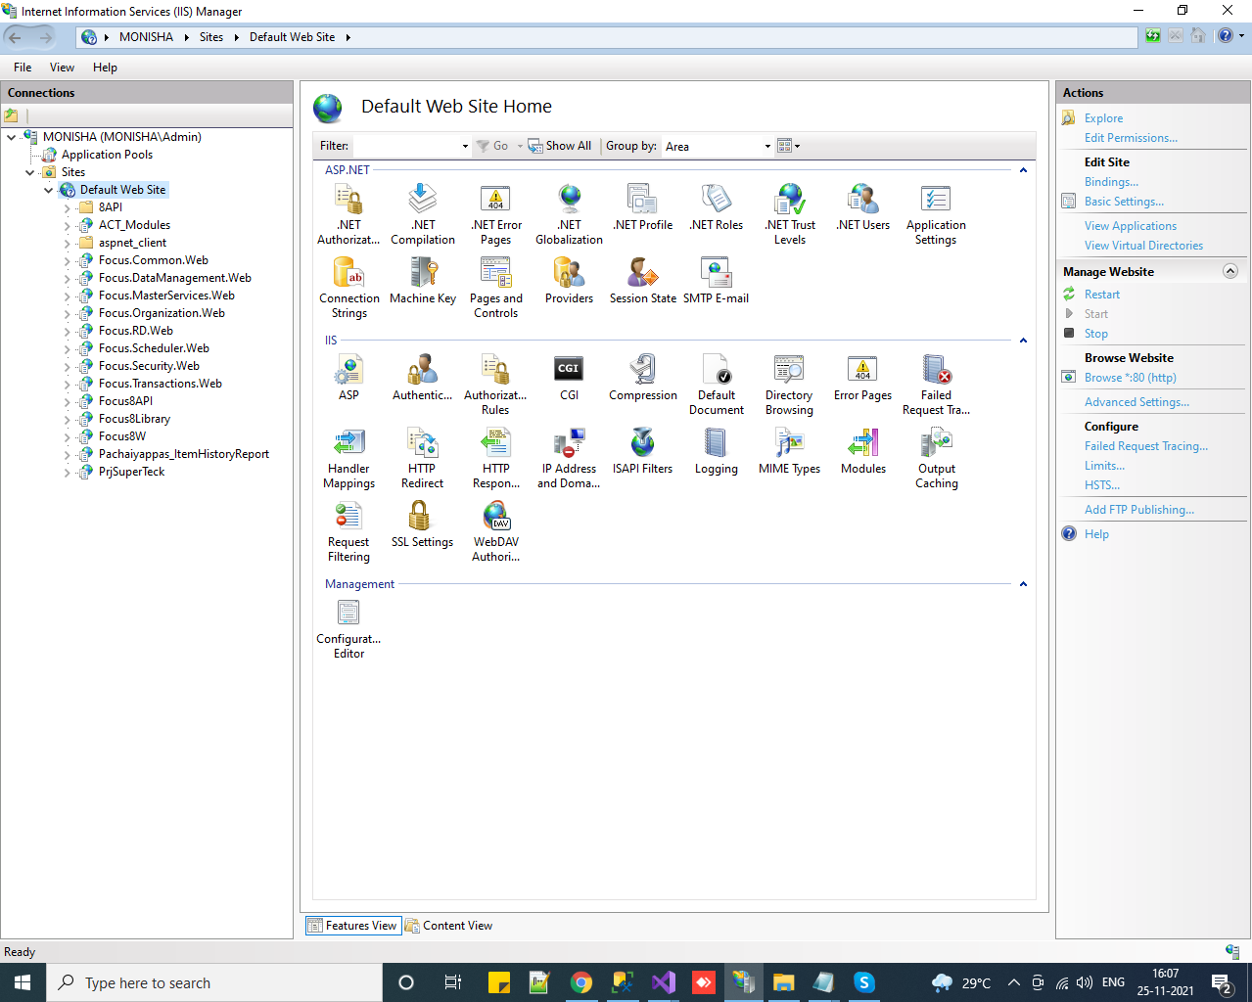

Open KamdhenuBulkSMSReport folder in **C:\inetpub\wwwroot** paste the files provided as given Below image.

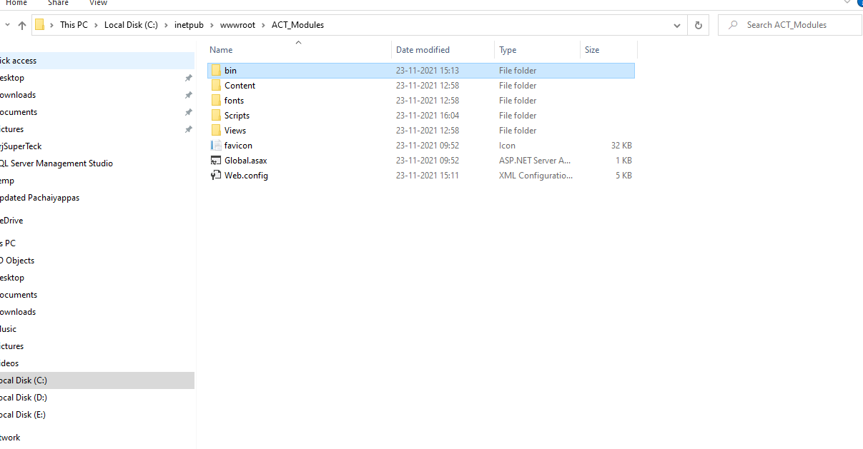

Open **C:\inetpub\wwwroot\** KamdhenuBulkSMSReport **\bin\XMLFILES**

Set **Data_Source, User_Id & Password** inDBConfig.xml

Bank PayMents

On Event - **AfterSave**

Module Type - URL

URL - http://localhost/KamdhenuBulkSMSReport/Scripts/Focus.js

Function Name - FnBulkSMSTransaction